AGRI-TRACTORS BOTSWANA
“Your partner in modern farming”
Agri Tractors Botswana is an online platform designed to make farming equipment easily accessible to farmers and agricultural businesses. The website allows users to browse a wide range of tractors and make purchases directly online.

- Website Specification
- The objectives and goals of the website:
. To promote tractors business online
. To allow product comparison
. Improve accessibility to customers
. To display detailed information about each tractor
. Allow users to search for tractors
. To provide a better shopping experience
. To reach more customers
- Target audience
The target audience includes farmers, agricultural businesses, and individuals interested in buying tractors.

. Age: 25 – 65 years
. Location: Rural and urban areas across Botswana
. Occupation: Farmers, farm owners, agricultural workers, and agribusiness companies
. Customers must be able to afford tractors

Technical brief:
Users must be able to:
- Use a smartphone or computer
- Browse websites
- Click buttons and navigate pages
- Buy products online

Type of website:
The website is an e-commerce website focused on selling tractors online.
Because customers can.
. Browse different tractors
. View tractor details
. Make purchases online

Information Design & Taxonomy

- Home
- Products (Tractors)
- Tractor 1
- Tractor 2
- Tractor 3
- Sign In
- Cart
- Checkout

Home
│
├── Products
│ ├── Tractor 1
│ ├── Tractor 2
│ └── Tractor 3
│
├── Cart
|-----Checkout
|-----Sign in
The website is organized into clear categories such as Home, Products, Cart, Checkout and Sign in
Technical Brief:
. HTML – used to create the structure of the website (pages like Home, Products, Cart, Checkout).
- CSS – used for styling the website (colours, layout, fonts, and design).
- JavaScript – used to add functionality (add to cart, navigation, form validation)
- Bootstrap – make the website responsive and well-designed and it helps the website automatically adjust to different screen sizes.
Page Template:

Low-Fidelity Wireframe
HOME PAGE

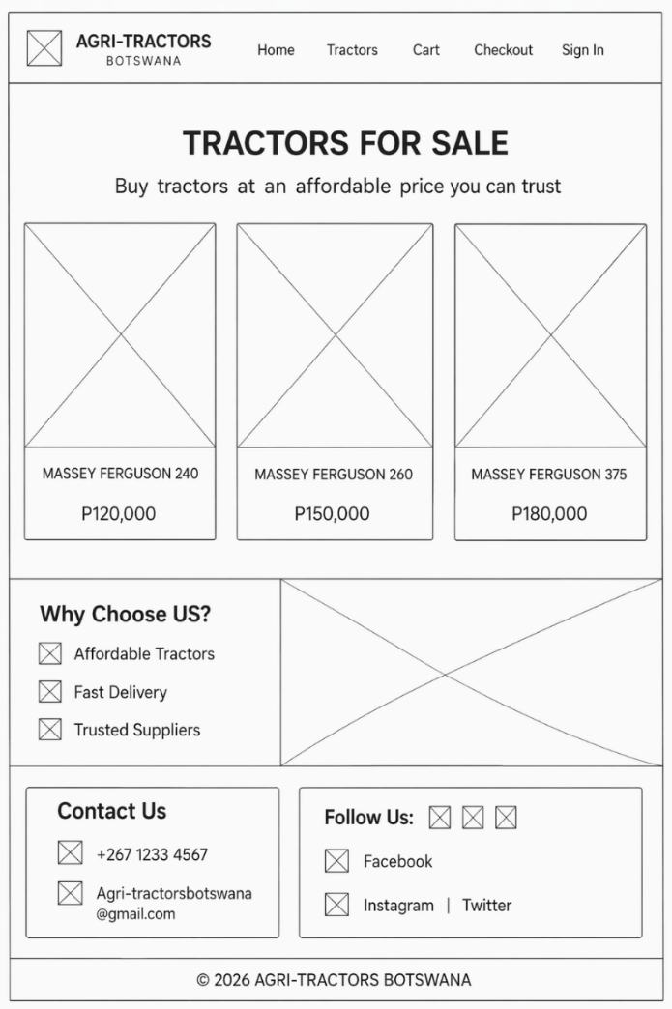

Tractors page

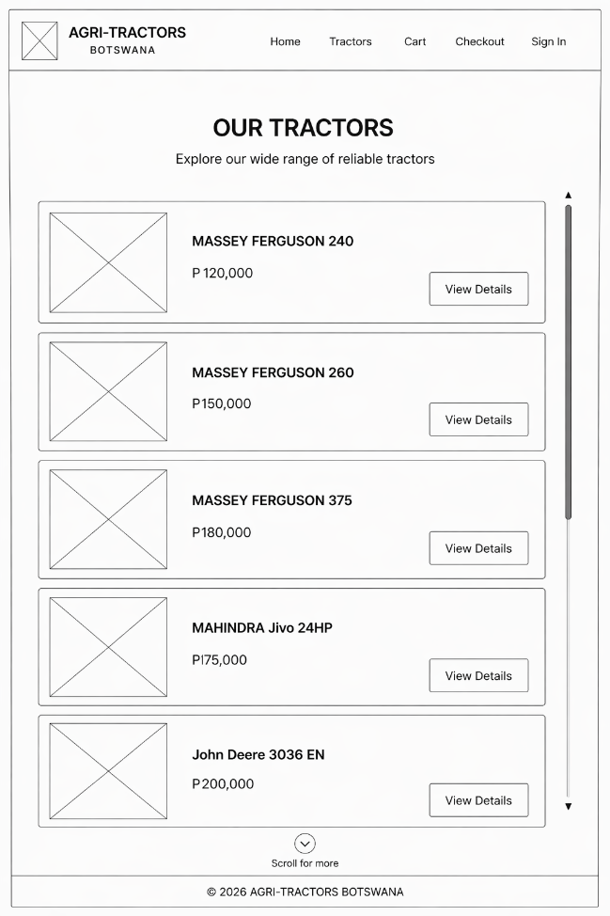

This wireframe shows the basic layout of my e-commerce tractor website and how different parts of the page are organised
At the top, there is a navigation bar with links such as HOME, TRACTORS, CART, and CHECKOUT, which allows users to move between pages.

The main section displays the tractors in separate product boxes, each containing a product image, name, price, and a “View Details” button. This shows how users can browse and select products.
At the bottom of the website, we see how an individual can get in touch with the company, the contacts and social media platforms for the company.

High Fidelity Wireframe

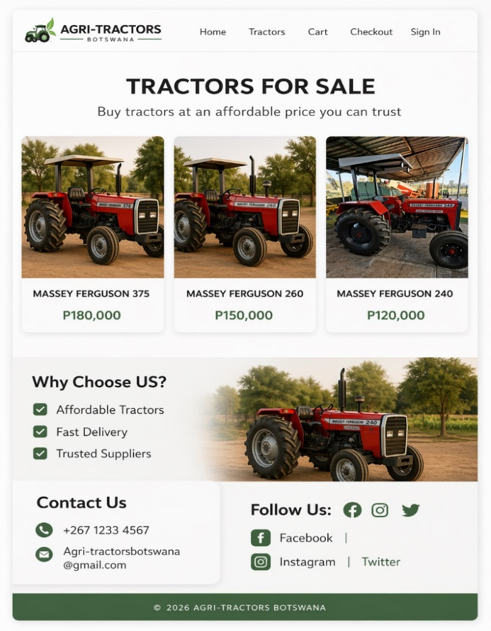
TRACTORS PAGE
